**Female Reproductive Cycles**

Female reproductive cycles:

1. Ovarian cycle – The **changes in the follicles within the ovary** throughout a 28-day cycle.
2. Menstrual cycle – The **changes in the uterine lining (endometrium)** throughout a 28-day cycle.

Ovarian cycle:

* Includes the **maturation of an egg** and its **release into a uterine tube**.
* Involves the **development of follicles** in the ovary and the **formation of the corpus luteum**.
* Primary follicle: A sphere composed of a **single layer of cells surrounding an immature egg** within the ovary.
* During puberty, some primary follicles undergo further development; cells forming the wall begin to enlarge and divide, **creating a layer of cells around the developing egg**.
* Secretions of these cells create a fluid-filled space that gradually forces the egg to the edge of the follicle; it’s now referred to as a **secondary follicle**.
* Only **one secondary follicle completes development in the ovarian cycle**.
* As more fluid accumulates within the follicle, it continues to **enlarge** and gradually **move towards the surface of the ovary**.
* On reaching the surface it produces a bulge on the surface of the ovary; it’s now referred to as a **mature follicle** (Graafian follicle).
* It usually takes 10-14 days for a primary follicle to develop into a mature follicle.
* Ovulation: The expulsion of the egg when the mature follicle bursts.

Ovarian cycle events:

Day 1: First day after completion of menstruation from the previous month’s cycle.

Day 1-14:

* **FSH acts on the follicles** within the ovaries.
* During this time, the **follicle grows several cell layers** and the amount of **fluid increases**.

Day 14:

* Due to the progressive increase in oestrogen (because of increase in FSH over the 14 days), the **oestrogen levels reach a stage where it inhibits FSH secretion**.
* The **decrease in FSH causes a spike in LH**.
* The **LH spike causes ovulation** (the expulsion of a mature ovum) from the ovary.
* At ovulation, LH forms a structure called the **corpus luteum** from some cells left in the ovary at ovulation.
* Note: The **mature ovum** that’s released moves into the **Fallopian tube**.

Day 15-21:

* The **corpus luteum releases progesterone** which **grows the endometrium in case fertilisation takes place**.
* Increased progesterone levels also **inhibit the release of FSH** from the anterior pituitary.

Day 21-28:

* If **no fertilisation** occurs, the **LH levels decrease** and **there isn’t enough LH** to keep the corpus luteum viable. Therefore the **corpus luteum degenerates** into the **corpus albicans**.

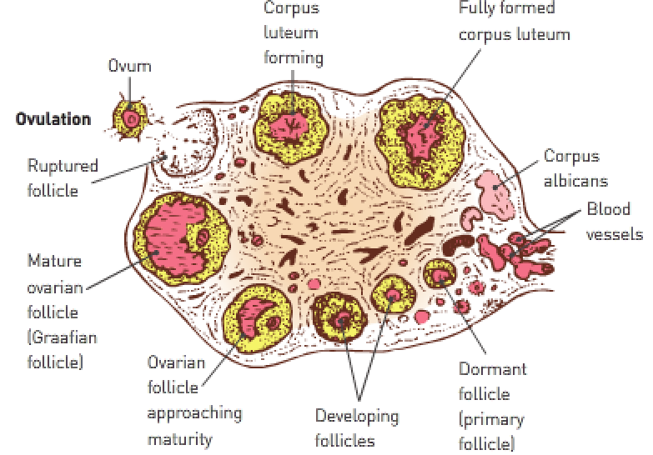

* Following ovulation, the **ruptured follicle collapses** and the **blood within forms a clot**.
* The clot is **gradually absorbed by the remaining follicle cells**, which **enlarge and change colour to form the corpus luteum**.
* Hormones that influence the development of the lining of the uterus (endometrium) are secreted by the corpus luteum.
* If **fertilisation hasn’t occurred**, the corpus luteum reaches its maximum development (8-10 days after ovulation) and then **degenerates into a fibrous mass of scar tissue called the corpus albicans** which **eventually disappears**.
* If **fertilisation of an egg takes place** and **pregnancy follows**, the **corpus luteum continues to develop** and the **ovarian cycles cease**.

**Menstrual cycle**: Changes in the **vascularisation** of the **endometrium**.

Menstrual cycle:

* The changes in the uterine lining (endometrium) are **in preparation for a developing embryo** in case the egg released at ovulation is **fertilised**.
* When the embryo reaches the uterus, it has to **implant itself in the endometrium**.
* In the **first stage of the ovarian cycle**, when the follicle is maturing, the **endometrium becomes thicker and softer**; there’s an **increase** in the **number of blood vessels and mucus-secreting glands**.
* After ovulation, the **endometrium continues to thicken**, and the glands within it begin to secrete a **watery mucus rich in glycogen**.

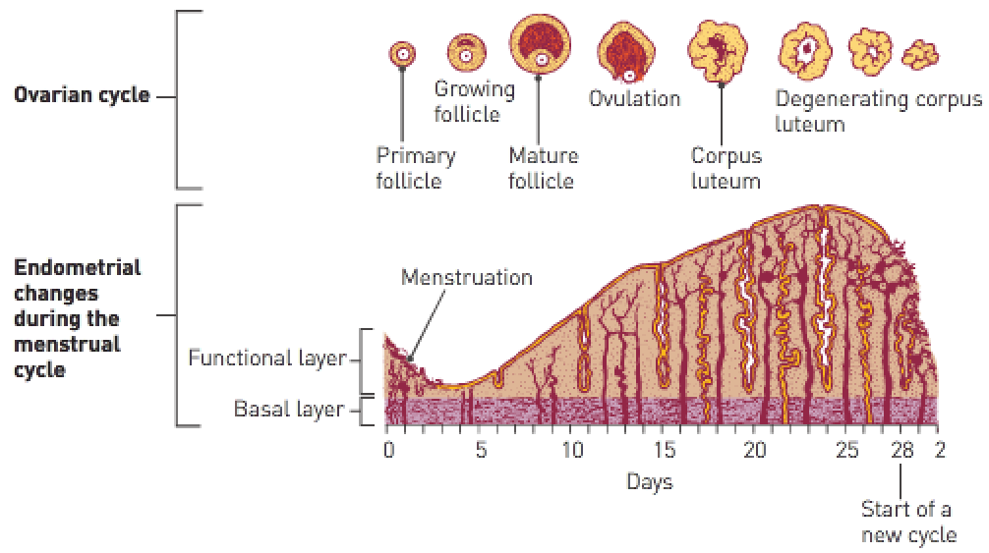

* If the egg **isn’t fertilised** by a sperm, the **corpus luteum degenerates**.
* 14 days after ovulation, **blood from broken-down capillaries, mucous secretions and cell debris from the uterine lining are lost through the vagina** – menstruation (menstrual period/period).
* When **menstruation first begins**, it’s called **menarche** – this is the **start of puberty**.
* Menstrual cycles last until menopause when the **processes that occurred at puberty are reversed**; the **menstrual cycle becomes irregular** over a period of years until it **eventually ceases**.

|  |  |  |
| --- | --- | --- |
| **Stage**: | **Time span (days)**: | **Events**: |
| Menstruation | 1-4 | * Uterine bleeding. * Shedding of the endometrium. |
| Preovulation | 5-12 | * Endometrial repair begins. * Development of ovarian follicle. * Uterine lining gradually thickens. |
| Ovulation | 13-15 | * Rupture of the mature follicle, releasing the egg. |
| Secretion | 16-20 | * Secretion of watery mucus by glands of the endometrium, cervix and uterine tubes. * Movement and breakdown of unfertilised egg. * Development of corpus luteum. * Most fertile stage (when corpus luteum forms). |
| Premenstruation | 21-28 | * Degeneration of corpus luteum * Deterioration of endometrium. |

Menstrual cycle events:

Day 1-4: Menstruation – The degenerated corpus luteum means that **progesterone isn’t available** to maintain the blood vessels of the endometrium. Therefore, the **endometrium is shed**, and a **period occurs**.

Day 4-14: Proliferative phase – The **endometrial lining slowly grows in thickness**. The **oestrogen** secreted by the growing follicles **increases the endometrial thickness**.

Note: Just before ovulation the endometrium is **thick with blood vessels in case fertilisation occurs**.

Day 14-28: Luteal phase – The progesterone secreted by the corpus luteum **maintains the thickness of the endometrium**. The thickness is **maintained until the corpus luteum degenerates** and **no longer secretes progesterone**.

**WACE Study Guide**:

Functions:

* Ovaries – Produce ova and release one ovum every 28 days.
* Uterine/Fallopian tube – Transports the ovum from the ovary to the uterus by cilia and peristalsis.
* Uterus – Protects and provides nutrients to the developing embryo and foetus during pregnancy.
* Vagina – Allows the baby to move form the uterus to the outside environment; also receives sperm to be inserted into the female reproductive system; allows the endometrium to be discharged every 28 days.
* Testes – Produce sperm.
* Epididymis – Network of tubules in which sperm mature.
* Vas deferens – Carry sperm up the epididymis to the urethra.
* Urethra – Tubule which carries sperm from the male reproductive system.

Maternal and foetal blood don’t come into contact because they’re separated by a membrane which allows nutrients and wastes to cross but not larger blood components.

The hormone prolactin increases in production during pregnancy but while progesterone is present in the blood, it inhibits prolactin acting on the breasts. After birth, when the level of progesterone falls, prolactin causers the milk to be secreted.

There’s a 40% increase in blood volume in a pregnant woman because a large quantity of blood must flow through the placenta.

The corpus luteum, releases progesterone which helps to maintain the endometrium so that the developing embryo remains in place after implantation.

At puberty, one oocyte completes Meiosis I. Now called a secondary oocyte, it’s released under the influence of an LH surge.

Embryonic stem cells differentiate into spermatogonia in the testes.

Testosterone causes primary spermatocytes to undergo meiosis.

Spermatids mature in the seminiferous tubules and the epididymis.

Spermatogenesis vs oogenesis:

|  |  |
| --- | --- |
| Similarities: | Differences: |
| One diploid gamete divides to form 4 haploid gametes. | Spermatogenesis – 4 small motile cells are produced which don’t have much cytoplasm and have little store of energy.  Oogenesis – Only one viable gamete is produced (and 3 non-viable cells) which has most of the cytoplasm and is much larger than the spermatids. |

|  |  |
| --- | --- |
| **Stage**: | **Information**: |
| Menstruation | * Lasts around 5 days. * Blood, tissue, fluid, epithelial cells and mucus are shed from the uterus. |
| Preovulation | * Lasts between menstruation and ovulation (day 6-14). * Oestrogens, released by the developing follicle, stimulate repair of the endometrium by promoting cell division (to thicken the endometrium) and the growth of the endometrial glands and blood vessels. |
| Postovulation | * Lasts between ovulation and menstruation (day 15-28). * Progesterones, released by the developing corpus luteum, continue the growth of the endometrium in preparation for implantation. * Endometrial glands are filled with fluid, further blood vessel development or vascularisation occurs and there’s an increase in the amount of tissue fluid. * If implantation doesn’t occur, progesterone levels fall after day 23 (as the corpus luteum degenerates) and the endometrium begins to break down. |